**Hive**

* First I have downloaded hive3.1.3 from the mentioned link.
* Then unzipped the compressed file.
* Setup the environement

**export HADOOP_HOME=/home/hadoop/hadoop-3.2.4**

**export PATH=$PATH:$HADOOP_HOME/bin**

* I verified the path of the hive by command

**Echo $HOME_HIVE**

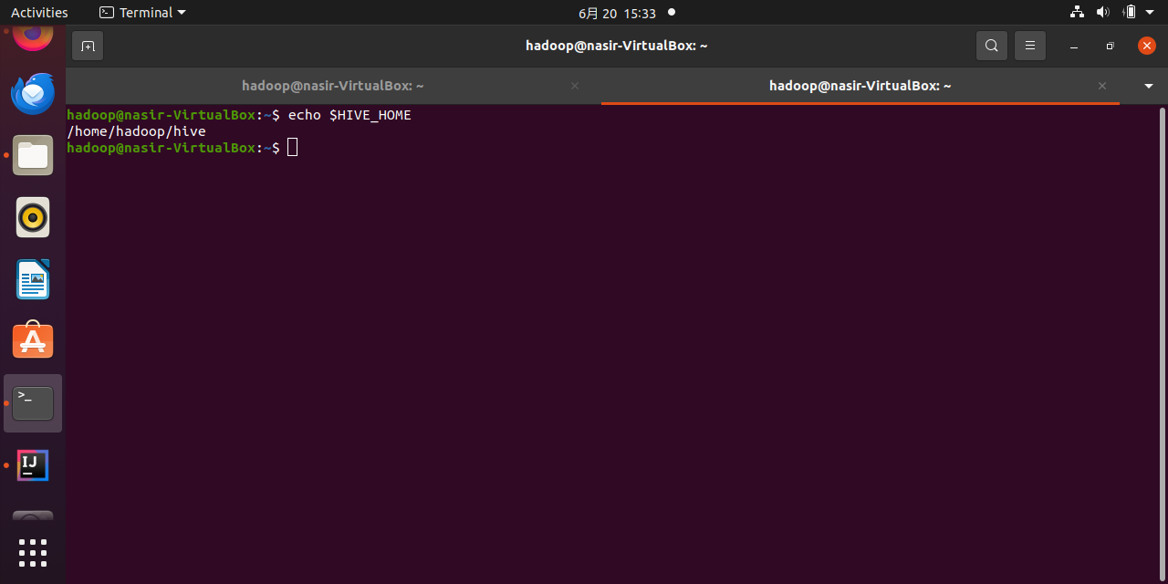

* Started Hadoop .

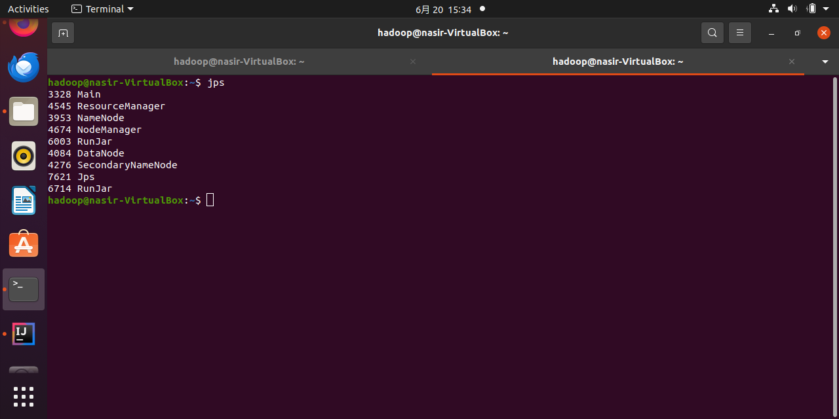

* Enter the command hive to enter the hive shell.

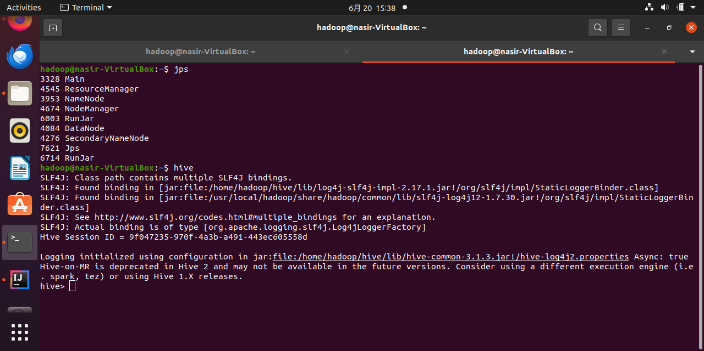

* dfs -ls /user/hive/warehouse/word_count;

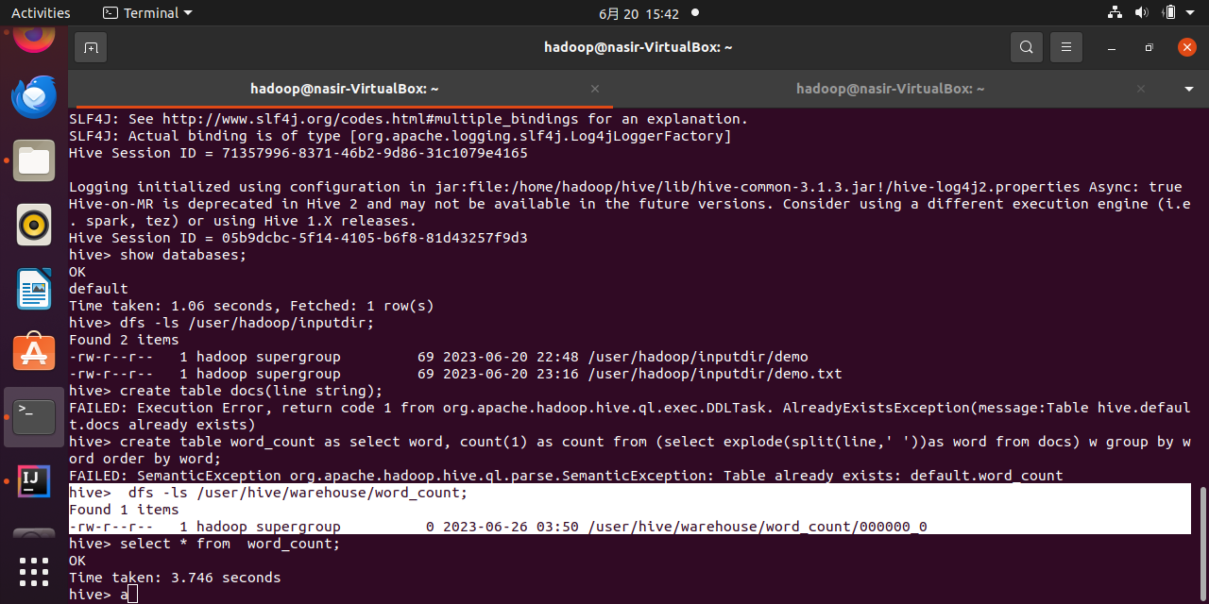

* **select * from  word_count;**

